Tab 1

Vector Store
28.06.2025

Vector Store
Vector store is a system designed to store and retrieve data represented as numerical vectors.

Features
- Storage - their associated metadata are retained , whether in-memory or on-disk.
- Similarity Search - retrieves the vector most similar to the query vector.
- Indexing - enables fast similarity searches for e.g. calculating centroids by clusters.
- CRUD operations
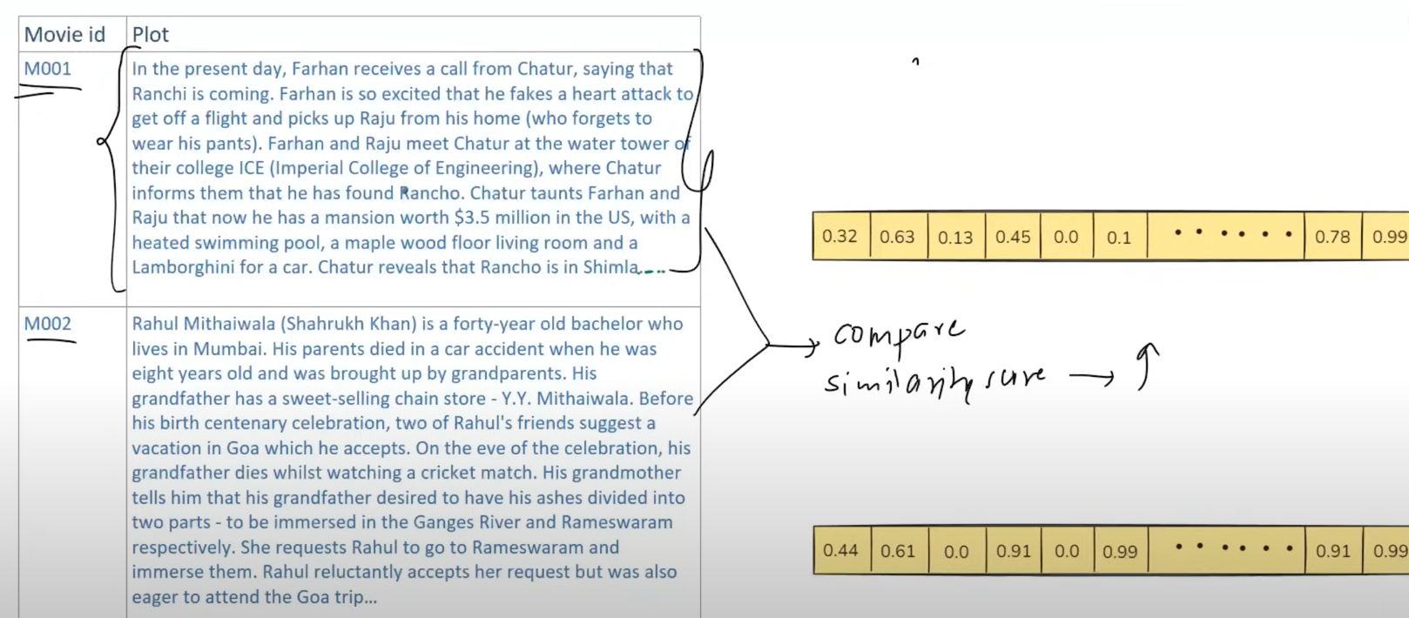
Use cases
Semantic Search
RAG
Recommender Systems

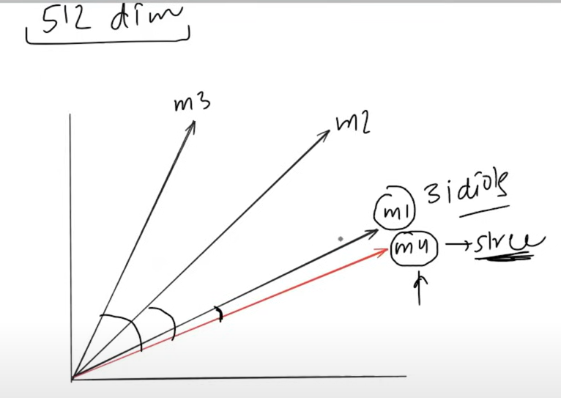



Vector Store Vs Vector Database
Vector Store | Vector Database
A vector store is a system designed primarily for storing and retrieving vector embeddings—mathematical representations of data like text, images, or audio in high-dimensional space. It is a lightweight library. | A vector database is a more comprehensive system that not only stores vectors but also provides advanced database functionalities like indexing, filtering, metadata management, and scalability.
🔹 Key Features:  - Efficient storage of high-dimensional vectors  - Fast similarity search (e.g., finding the most similar documents or images)  - Often used in retrieval-augmented generation (RAG) pipelines  - Typically lightweight and optimized for read-heavy workloads | 🔹 Key Features:  - All the capabilities of a vector store, plus:  - Metadata filtering  - Hybrid search (vector + keyword)  - Scalability and durability  - Access control and security  - Often supports distributed architecture

Vector stores in langchain :
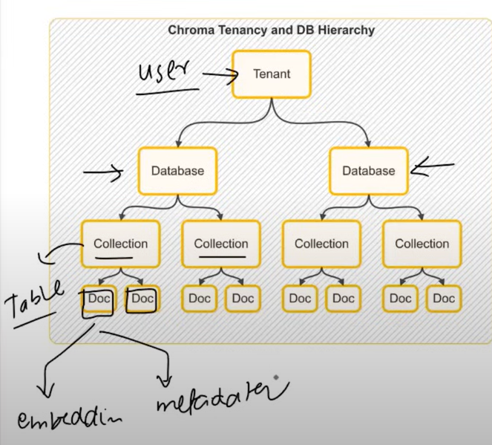
FAISS , Chroma , Pinecone , Qdrant , Weaviate etc. they all have a common interface and can be interchangeable . They can be filtered on the basis of Metadata-Based Filtering.

Chroma is a lightweight open source vector database for local development.

Tab 2

